INSTRUCTIONS FOR ACCESSING ONLINE SESSIONS
Contents
Joining the conference 2
Presentation options 4
Setup and presentation testing 7

Joining the conference
Please disconnect from any VPNs before accessing the online conference.
When accessing the link, you will be asked to enter your name and click the button Join. Please enter your full name.
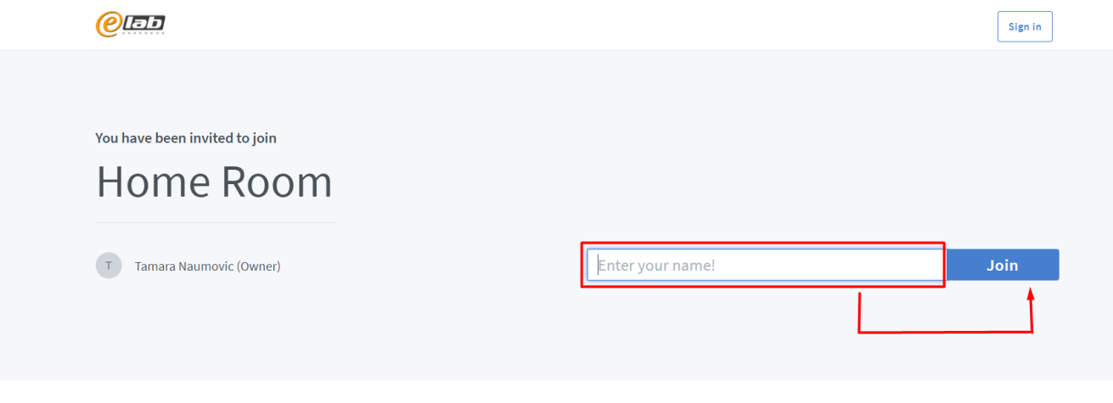
Figure 1 Home page - sign in
After initial joining you will be asked to join the conference with microphone or listen only - please choose Microphone option. Browser will ask you for microphone permissions – please allow it.
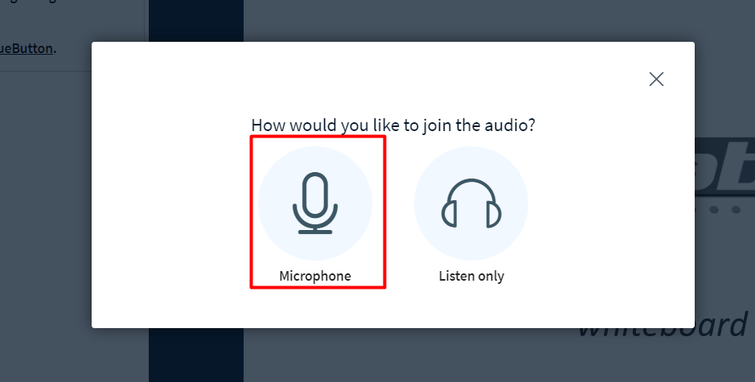
Figure 2 Join with microphone
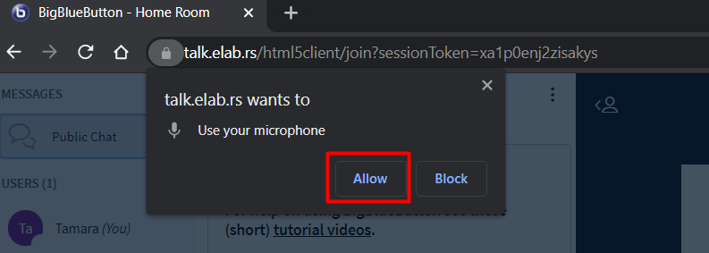
Figure 3 Allow microphone in browser
A window for with echo test will appear. Make sure you can hear yourself and click Yes.
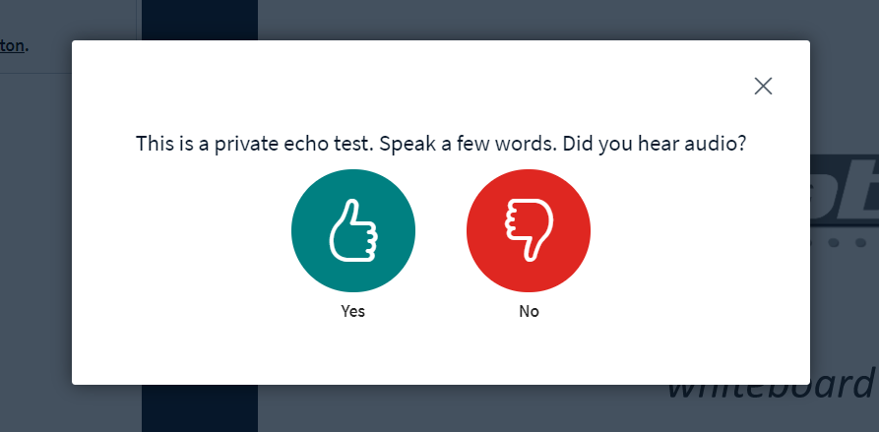
Figure 4 Echo test
If you successfully completed previous steps, you will be joining the conference.
Please mute your microphone when you are not speaking.

Presentation options
Left side of the window shows list of all participants (1), live chat (2), and main window with the presentation options (3).
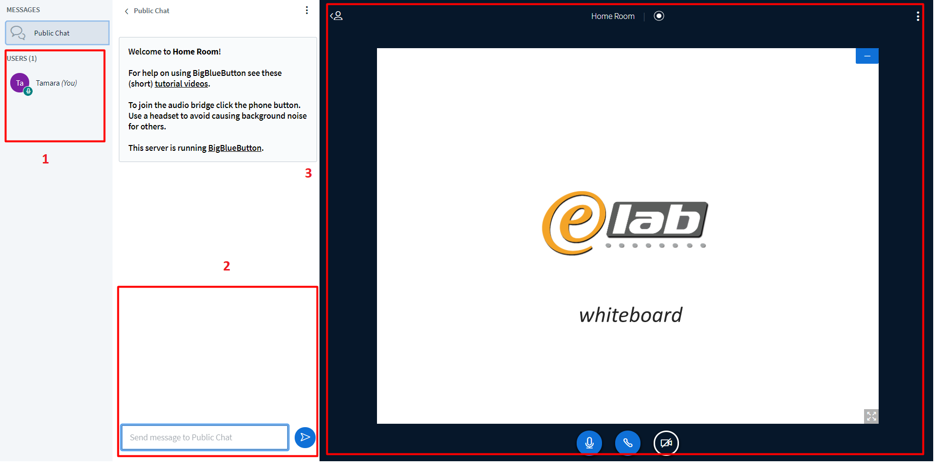
Figure 5 Conference window and options
In the left corner of the main window area Action (+) option is available. Clicking on it you are shown three options: Start a poll, Upload presentation and Share an external video.
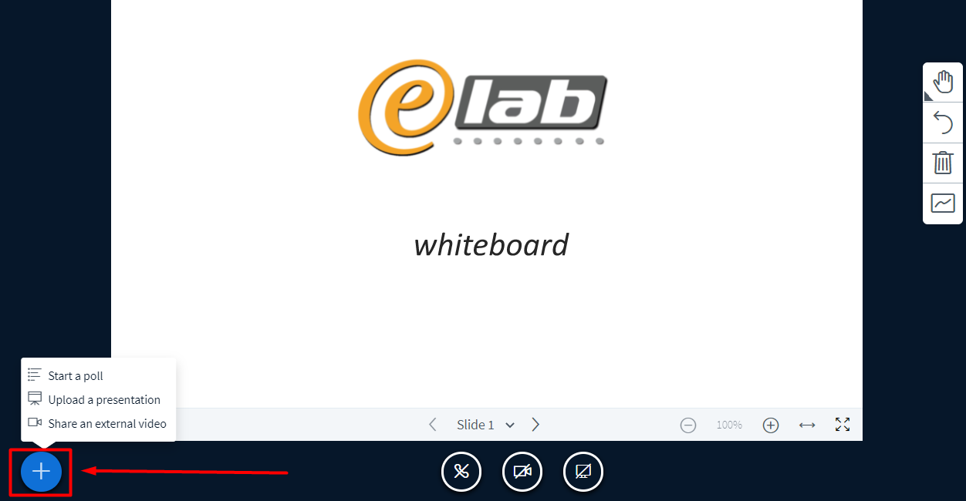
Figure 6 Add action
- Upload presentation option allows you to share your presentation to the main screen. Steps for sharing are as follows: choose the presentation from your computer and drag it to the drag window area, or click brows for files, upload the presentation clicking the Upload button. After a couple of seconds, your presentation will be visible in the main window. Presentation should be in PDF format.
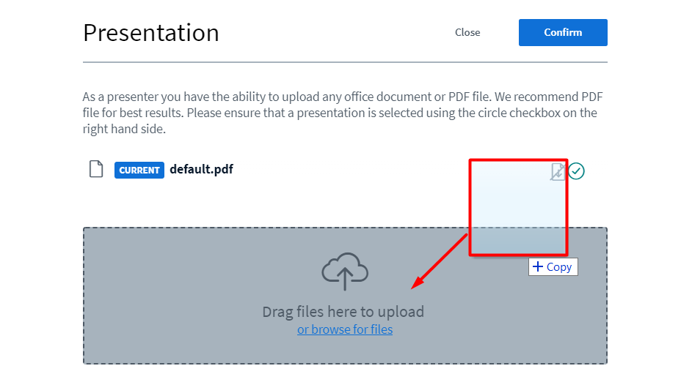
Figure 7 Browse for presentation
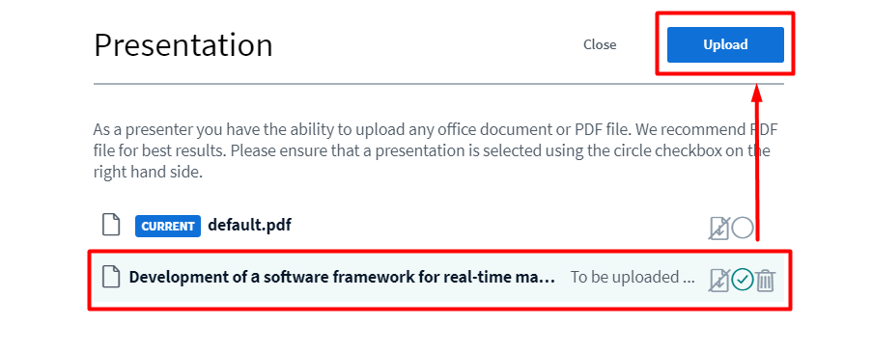
Figure 8 Upload presentation
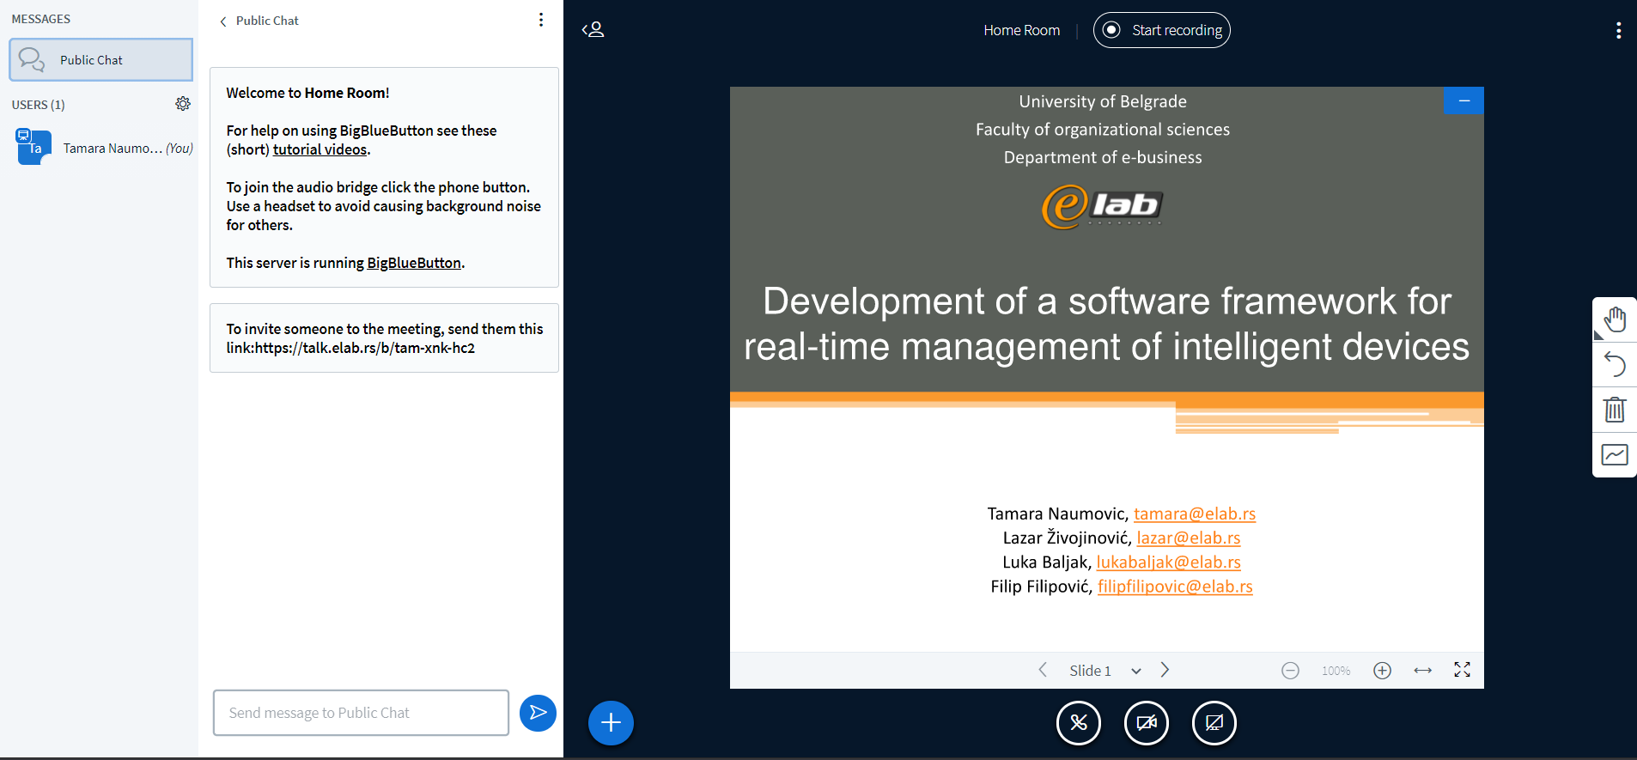
Figure 9 Presentation shown in the main window
Use left and right arrow to navigate through your presentation.
- Start a poll option allows you to organize and create a questionnaire for participants.
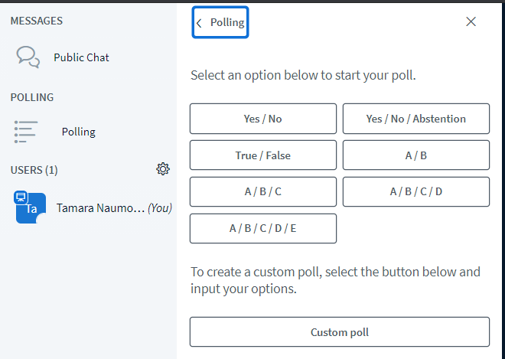

- Share an external video option allows you to share a video to participants. A pop-up window will appear where you can input the link to the video you want to share. Click Share a new video to show the video to participants.
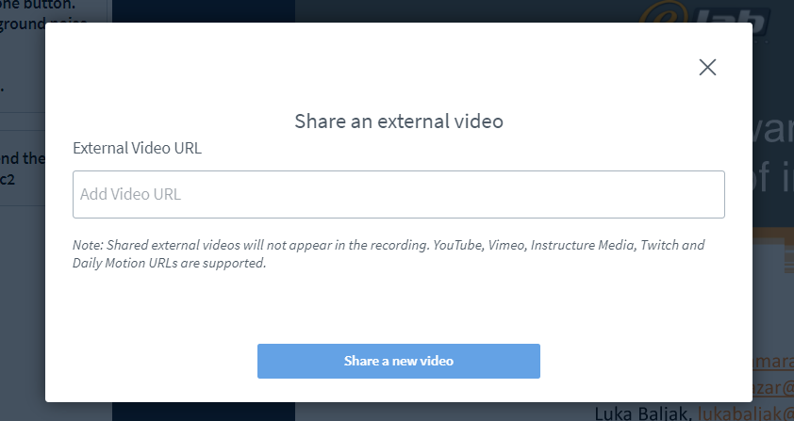
Beside Action options, in the bottom part of the main window, you have options to mute yourself, leave audio conference, turn on the web cam and share your screen.

Setup and presentation testing
Links to all online sessions will be available June 5-9th to all participants for presentation setup and testing.
On Wednesday 10-11h June 9, participants can test their presentation with technical support on the same provided links.
If you need any real-time assistance during sessions please contact prof.dr Zorica Bogdanović via phone/viber/whatsapp/telegram: +381698893331

